Technique

The power curve
Constructing a power curve—drag curve, if you like—for your trainer is an exercise that teaches valuable lessons in aircraft control and aerodynamics. As an added benefit, once you construct your graph and study it a little, you’ll know precisely what power setting to use for any given airspeed in level flight. You’ll also be able to identify the approximate indicated airspeed at which your aircraft enters the so-called “region of reversed command.”
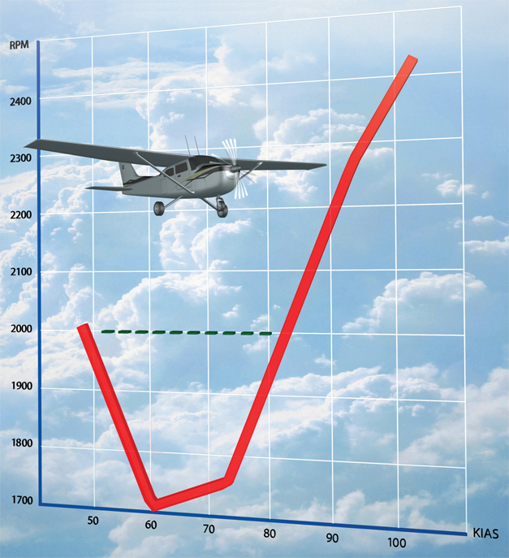
Click the images below for larger versions.
