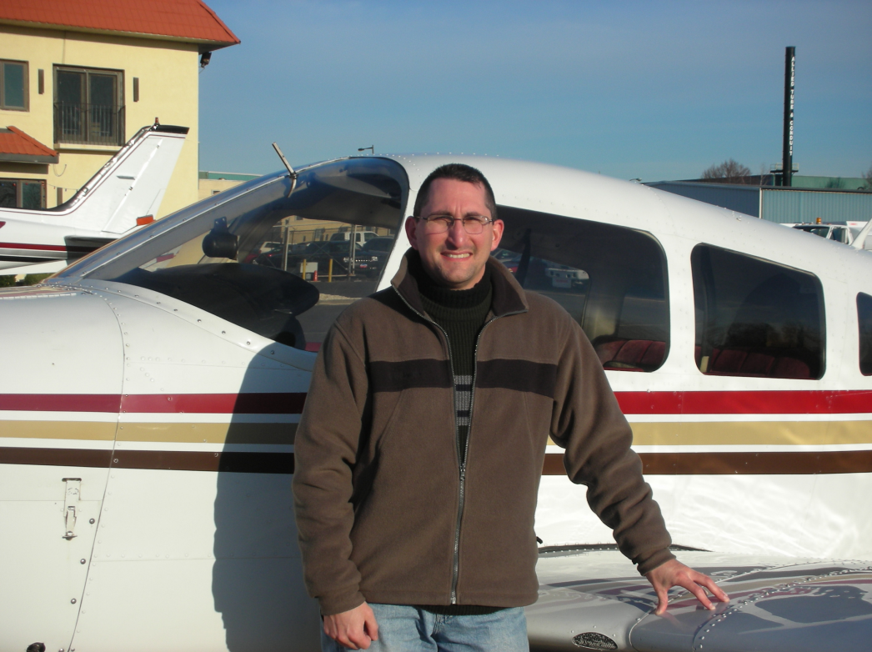

Fly Guy

Mar 1, 2013

Piper Archer

N8172N

Gillespie Field

San Diego, CA

______________________

Noah All, CFI

First Solo Flight