Detonation Myths

First appeared March 21, 1999, www.avweb.com

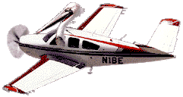
We've all been taught about detonation in piston aircraft engines. It's what occurs when combustion pressure and temperature get so high that the fuel/air mixture explodes violently instead of burning smoothly and it can destroy an engine in a matter of seconds. Right? Well, not exactly. AVweb's John Deakin reviews the latest research, and demonstrates that detonation occurs in various degrees — much like icing and turbulence — with the milder forms not being particularly harmful. Heavy detonation is definitely destructive, and the Pelican offers some concrete data on how to avoid it.
Before getting into this month's column, I'd like try and address one of the most common question I'm getting from readers of my series on piston engine operation:
"John, you talk about fuel-injected engines, but I don't have one. What can I do in my Cessna 182, with its O-470 carbureted engine?"
Managing Carbureted Engines
Folks, I wish I could help. Most carbureted flat engines have such atrocious fuel/air distribution they are beyond help. That's one reason the industry went to fuel injection in the first place, and even that was only an incremental improvement until GAMIjectors came along! In the usual flat six, you have six different engines out there, each running in its own way, at its own mixture setting. Some may be LOP, others ROP. In most carbureted Cessna 182s, the mixture difference between the richest cylinder and the leanest is incredible, beyond hope. This is one major reason the "65%" cruise power setting came into play. If you set the MP and RPM for 65%, and the mixture for "best power" (as driven by the marketing department at most aircraft manufacturers), that means the hottest cylinder will not be out of limits, and the TBO will be acceptable. Run it harder, and at least one cylinder will run too hot, probably not making TBO. The harder you run it, the fewer cylinders that will make TBO.
But at that 65%, some cylinders will be LOP (and more likely to make TBO and beyond), while others are very ROP, running very "dirty," contaminating valve guides with the unburned products of combustion, limiting their life. I firmly believe that as the years go by, and the data comes in, we'll see engines going to MUCH higher TBOs when run LOP on all cylinders, even at much higher power settings. Time will tell. Meanwhile, what's best for carbureted flat engines? About all you can do is set MP and RPM for 65%, lean the mixture until the engine runs rough, then enrich just barely enough to make it run smoothly again. No matter where the individual cylinders are running, you probably won't hurt them.
If you are high enough to cruise at full-throttle, there is one trick that may help on some engines. Lean as above, then pull the throttle out very slowly until you see the tiniest perceptible drop on the MP. That will cock the throttle plate within the carburetor just a little, and that may induce enough turbulence to mix the fuel and air a little bit better. Leave the throttle there, and try leaning again. You may be able to lean it a bit more before the engine begins to run rough. When flying in cold OATs, just a touch of carb heat can also help to even out the mixture distribution by improving fuel atomization. This trick is particularly useful with carbureted Continentals like the O-470 in Cessna 182s. Once again, this may let you lean a bit more aggressively before the onset of engine roughness. Is it worthwhile to get an engine monitor like the JPI if you cannot run LOP? Yes, I think so. Definitely on a big-bore engine. Maybe on a four-banger, too — that's less clear, and might depend on your typical mission. The information it will give you about your engine is very useful, and for troubleshooting alone, it may pay for itself. It's a lot of fun to pull up to your favorite shop and say, "Hey, my #2 cylinder, lower plug isn't working." One plug change, and you're on your way. Otherwise, your mechanic is likely to pull 'em all. Most other problems show up on the JPI, as well, giving you an early warning of impending problems. That just may cause a jug change, instead of a forced landing.
Now to Our Main Topic — Detonation
Thousands of trees have been killed putting words on paper about detonation, yet the subject is still not widely understood, and new information keeps coming in. There is some reason to believe that one engine used in a high-performance general aviation aircraft may operate in continuous light detonation on one or more cylinders on a frequent basis, even when operated exactly as the factory recommends. Frankly, I wonder how it ever was certified. Factory comments notwithstanding, operating LOP at the same power output (adding back MP) totally cures the detonation, and gives a wide margin, too. I always thought detonation was pretty simple. The classic explanation goes something like this:
"The combustion event begins with a spark, rapidly builds pressure in the portion of the fuel/air mix that hasn't burned yet, and as that pressure builds, the temperature increases. Once the temperature gets hot enough, the remaining mixture "explodes," causing a hammer-like blow to the piston.
"Detonation can cause catastrophic engine failure within a few seconds."
Well, maybe. But there are several troubling questions that arise from this reasonably correct but terribly simplified explanation. (Oh, and folks? Please don't quibble with me over whether or not it's really an "explosion." Whatever you want to call it, it's an abnormally fast burning, and that's close enough to "explosion" for me.) For completeness, it is worth mentioning that "detonation" refers to abnormal explosion(s) AFTER the normal ignition. If spontaneous ignition occurs before the spark plug fires, that's a different and far more dangerous condition: "preignition." Either condition can lead to the other, and once they start working together, catastrophic engine failure is only seconds away.
For one question, how about "pinging," in older cars? Most of you will have heard this sound, a fairly rapid, high-pitched knocking from an automobile engine. It usually occurs when laboring up a hill, with the manual transmission in too high a gear (low engine RPM), and the gas pedal well down (high manifold pressure). That's detonation. You won't hear it in an airplane for a couple of reasons. First, there are no mufflers on airplanes (see below), and the high noise level masks the sound. Second, the audible "pitch" of the sound is directly related to the size of the cylinder bore, with "big-bore" aircraft engines emitting a much lower-pitched sound. That sound is far more likely to be lost in the noise of the engine itself. Some older cars knock a lot when going up uphill, and still seem to run for tens of thousands of miles with no obvious distress. (Yes, there are "muffs" in airplane engines, which look like mufflers, but they are primarily air-to-air heat exchangers. They are provided to extract some heat from the outside of the hot exhaust pipes for carburetor heat, or cabin heat, and have little or no effect on noise.)
Light, Medium, and Heavy
A few years back, some of the research done by General Aviation Modifications Inc. (GAMI) in Ada, Okla., began to raise further questions in my mind about detonation. George Braly, the founding genius and chief engineer, started running a highly instrumented engine deep into detonation, and recording data that no one had ever seen before. What he found supported the dirty little secrets discovered so long ago in the heyday of the big radials, and mostly forgotten today. Racing folks know a lot of this stuff, but are generally very secretive, not wanting to pass their precious knowledge on to competitors. The old books and even FAA publications speak of "light" detonation, "medium" detonation, and "heavy" detonation. But wait! How can that be, if detonation is the instantaneous "explosion" of the remaining charge, and that explosion can cause nearly immediate destruction of the engine? This doesn't compute!

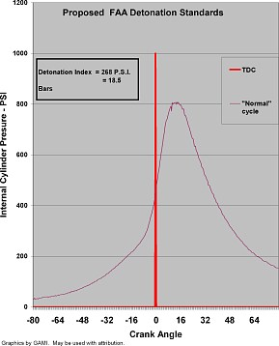  Normal combustion — no detonation. | 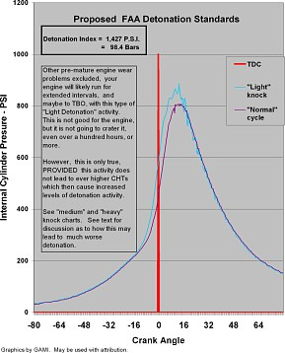  Light detonation.
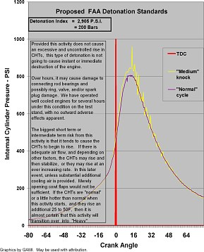  Medium detonation. | 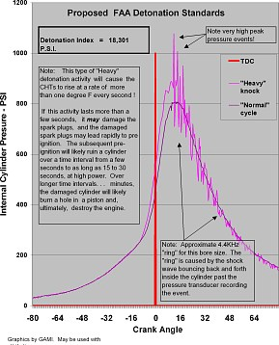  Heavy detonation.
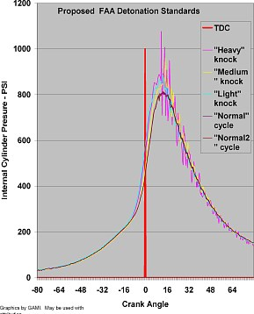
Composite: light, medium, heavy.

As usual, there is more to the story.
Instant Replay of a Detonation Event
What I am going to describe for you is a composite of my understanding of the detonation phenomenon. You won't find this description in any single textbook. You will find bits and pieces of it in different textbooks, but, so far as I know, the description below pulls together the bits and pieces from a lot of different places. Some of it has probably never been described in this precise manner, at least not to my knowledge. It turns out that even in a well-balanced charge of fuel and air, there are highly localized "pockets" of varying mixtures at the "local level." By "local level" you should think of a bunch of little fuel molecules huddling together "over here" and "over there" in different places inside the cylinder as the piston is rising up towards top dead center and starting down. Some of these pockets may be so lean (or so rich) that they won't burn at all, some may be in the combustible range, and some may be perfectly mixed, "ready to go," so to speak.
As an aside, this explains another little mystery. In theory, the "ideal" mixture for our engines is about 15 parts air and 1 part fuel (by weight), which should result in no oxygen and no unburned fuel molecules going out the exhaust pipe. But we've long known that a slightly richer mixture would produce slightly more power. Why? Because the theory breaks down a little when the charge contains those little pockets of varying fuel-air mixtures. Some of the oxygen molecules do not find fuel molecules quickly enough to burn, and they remain unused or unburned at the ideal ratio. By supplying just a bit more fuel for the lonely oxygen molecules, more total fuel is burned, a bit more heat is generated, and less oxygen escapes out the exhaust pipe without having had a chance to mate. You can see this for yourself, for all the old radial charts show it, and both Lycoming and TCM produce charts that show CHT peaks at about 30 ROP, while maximum power occurs at about 80 ROP. The 15:1 ratio occurs, essentially at what we all know as our familiar "peak" EGT on our engine monitors.
Now, somewhere about 20 to 25 degrees before the piston reaches top dead center (TDC) of piston travel, the spark plug lights the fire. The flame front starts spreading from each spark plug, slowly at first, then more rapidly within the cylinder. This flame front plays an important role in all of this. Ever stick your hand up close to a hot flame? Not in the flame, just close? It gets hot fast. There is a LOT of infrared heat being given off by that flame front. It travels at the speed of light. Maybe a few million times (or so) faster than the flame front is traveling across the cylinder. That infrared radiation heats up those little local pockets of fuel and air. Further, since the piston is rising rapidly in the cylinder, those little remote local pockets of fuel and air are also experiencing a sudden rise in pressure. Still further, because the flame front is a combustion process, it, too, is causing a further and much larger rise in pressure in the cylinder. Hold that thought for a moment, while we mention the time scale for all this.
During the combustion event, the speed of sound (at the higher bulk gas temperatures) is such that a sound wave can bounce across the cylinder and back in about 1/5000th of one second, or about 1/5th of a millisecond. This is easy to instrument and measure. You see the evidence of this in the little detonation shock waves bouncing back and forth past the pressure transducer on the back side of the down slope of the combustion pressure event in the graphics depicting the medium and heavy detonation. The crankshaft is rotating about 45 times per second and that works out to about 22 milliseconds for each crankshaft rotation, or about 16 degrees of crankshaft rotation for each millisecond. So in the time it takes a shock wave to travel back and forth across the inside of the cylinder, the crankshaft has only moved about three degrees.
So, now that we have the time scale firmly in mind, we go back and summarize what is going on:
- We have nice cool induction air and fuel entering a cylinder;
- The cylinder happens to have very hot walls. Those hot walls cause some of that nice cool induction air to start to heat up. And it doesn't all happen uniformly.
- Further, shortly after the sparks go off, we have a couple of flame fronts, giving off lots of infrared heat, adding to the continuing heat load being absorbed by some of those little remote pockets of fuel and air that are waiting for the flame front to arrive and consume them;
- The unburned mixture is experiencing a very rapid increase in pressure, because of two things: A) The piston is rising rapidly during the compression stroke; and B) the flame front combustion products are creating a huge increase in released energy and resulting bulk gas pressure, all of which is neatly measured on the pressure traces you see in the accompanying graphics.
- At least some of those little "local pockets" of unburned combustion mixtures have exactly the right mixture of fuel and air to be just a hair-trigger away from exploding.
- And … if the fuel is the wrong octane, or the spark advance was set too soon, or the manifold pressure was too high, or the cylinder head temperature was too high ... then one or more of those little "local pockets" of unburned fuel do just that ... they "explode."
That is what we call "detonation".
Each explosion creates a shock wave that travels at the speed of sound (remember, the speed of sound inside the cylinder, at somewhere near 4000 degrees, is very much faster than at a standard day!) and bounces off the walls of the combustion chamber every 1/5th of a millisecond or so (giving off a 5KHz "ping" that you will not hear in the cockpit). Each of those explosions creates a very sharp rise in pressure and sets off a shock wave, which vibrates back and forth across the cylinder. This shock wave can be just the right amount of additional pressure to cause some other little remote local pocket of fuel and air to, in turn, explode, adding to the problem.
As detonation grows more serious, it will become audible, and this is the pinging you'll hear from that old auto engine on the uphill grade. Remember, you will NOT hear it on an aircraft engine.
Let's Talk Temperatures
We know that combustion temperatures are in the 3,000ºF to 4,000ºF range, but TIT and EGT "only" run around 1,600ºF, and CHTs down around 400ºF. How can this be? 4,000ºF is more than enough to melt steel, so how does the interior lining of the cylinder survive? Why don't we see hotter temperatures on our instruments? Why doesn't the aluminum piston melt down, when aluminum melts at less than 1,000ºF? There is a "thermal boundary layer," on the order of a millimeter thin or so, that acts as a buffer to protect the steel cylinder walls and the surface of the aluminum piston. Think of it as the thermal equivalent of the aerodynamic boundary layer out on your wing. The metal and the molecules right next to it will be at roughly the CHT reading or a bit higher, the next layers will be hotter and hotter, until the layer next to the combustion event will be at the combustion temperatures. That very thin thermal boundary layer acts as a nice insulation barrier, limiting the rate at which heat can be transferred from the bulk combustion gases into the interior walls of the cylinder head, cylinder barrel, and piston.
The heat transfer is continuous, as the heat moves first through the boundary layer, and then the cylinder wall and is finally carried away by the cooling airflow around the fins on the cylinders. Each intake stroke brings in a cool new charge, which starts the process all over again. There is also a matter of time of exposure. The high-pressure part of the combustion event takes up only about 40 degrees or so of crankshaft rotation, and the very hottest part of that only about 20 degrees, so during the other 700 degrees of crank rotation, cooler temperatures prevail. Many pilots mistakenly focus on the temperature of the exhaust gas as measured by their familiar EGT probes. EGT shows only a number that represents a momentary flash of heat during a small portion of the combustion cycle (when the exhaust valve opens and exhaust gas flows across the EGT probe), and a rapidly dropping temperature at that. This is NOT the major factor that determines how hot their exhaust valve is during operation. The events that happen a few degrees of crankshaft rotation earlier are much more significant because the temperatures are MUCH hotter than the piddling little 'ol 1500ºF measured by the EGT probe. Once detonation becomes serious enough, it disrupts the previously well-organized thermal boundary layer and allows a greatly increased rate of heat transfer from the very hot bulk combustion gases (up around 4,000F) into the cylinder head and the piston. This last stage in the process is what starts the damage, and drives the CHTs up.
How Damaging Is Detonation?
There are newly proposed "standards" that define "light," "medium," and "heavy" detonation. How those are arrived at is far too complex to go into here (which means "I don't know"), but suffice it to say that a little light detonation, even for hours at a time may not be harmful, and in fact, can be beneficial. It does a marvelous job of cleaning deposits off the top of pistons, for example! The truth of the matter is, most of these engines can operate in the light detonation condition as shown in the graphics for several hundred hours with no detectable damage, PROVIDED the CHTs remain cool and you do not experience a runaway cylinder head temperature during the process. The problem is how to detect it, and prevent it from becoming worse, because "light" can progress rather quickly into "medium" and worse. It is a "positive feedback" process, with a very negative result!
The mechanism that causes it to be self-feeding is that the shock waves from the light detonation tend to begin to "scrub" the thermal boundary layer inside the cylinder. As that happens, the rate of heat transfer increases from the bulk combustion gases into the cylinder. That starts the CHT rising. When the CHT rises, it tends to heat up the incoming charge of new air and fuel a bit faster than the previous crank rotation, and that increases the likelihood of there being more light detonation in the next combustion cycle, which increases the disruption of the thermal boundary layer even more, which heats up ... well, you get the picture. If the cylinder is not really well-cooled, with some cooling reserve, the whole process can snowball to hell in a hurry and you end up in deep detonation trouble. That would be bad, because at some point, detonation is definitely harmful over the long haul. Braly has run his "Little Engine That Could" deep into heavy detonation for hours on end, and has put a lot of similar time on a poor old IO-470, and an IO-520 trying to destroy the engines. They still run pretty well (Well, sorta pretty well!), but you really wouldn't want those engines in your airplane.
Now, am I recommending detonation? Definitely not! But at the same time, it is not quite the fearsome monster we've all been led to believe. The approach to detonation is gradual, and even once it begins, it does not develop so rapidly that it cannot be caught and controlled. For the most part, some light detonation will not cause immediate failure. Even some short-term (a few seconds?) medium detonation probably won't cause an engine failure "right now," but it may well do some damage that will cause a failure some time in the future. I think we can all agree it's better to just stay away from detonation entirely. Much better!
Detonation is a very serious problem at the Reno races. Those engines are run at manifold pressures up to double the normal limits (which are already quite high). Some are run at several hundred RPM higher than design limits, with all sorts of fancy devices to inject strange stuff into the process. At those settings, any failure or miscalculation can cause almost instant heavy detonation, and destroy an engine in seconds. But in our world, it is very difficult to induce detonation in any engine without a supercharger. Even with supercharging, it's fairly easy to avoid it with a little knowledge.
George Braly writes:
"The truth of the matter is, if one does a very, very careful analysis of all of the Service Difficulty Reports, all of the NTSB accident reports, and sorts through the data, one comes to the conclusion that almost all of the detonation that is experienced by pilots is a result of the following:
- Fuel quality issues;
- Magneto and harness cross-firing, or improper magneto timing;
"There are some reports of detonation that were probably mis-classified as pre-ignition events due to damaged spark plugs or heli-coil problems in the cylinder.
"And, last, yes, there are some, a few, cases of detonation that are "for real" and were caused by very misinformed engine operating techniques by the pilot. If you get in a pressurized Cessna P-210 and decide to lean the engine in the mountains for your short field takeoff, because that is the way you used to do it when you had your normally aspirated C-210, then you can destroy the engine with pure detonation by the time you turn cross wind in the traffic pattern. It will absolutely ruin your day.
"However, in general, detonation is a very rare event and is usually caused by fuel or ignition problems."
Causal Factors
While improperly maintained or set up magnetos and fuel contamination are the most often observed direct causes of detonation, there are a number of factors that come into play to create, cause or prevent detonation. A further partial list might include octane rating of the fuel, mixture setting, induction air temperature, RPM, manifold pressure, cylinder head temperature, compression ratio, and probably more that I've forgotten here. I believe it was Jimmy Doolittle who said that the most important factor in winning WWII was the use of lead in avgas, which permitted the manufacture of 100/130 and 115/145 octane fuels. That, in turn, provided more powerful engines. Of course, that great man was involved in the research that led to the use of lead, so he may have been a little prejudiced. Everyone knows that Betty Grable probably had more to do with it. Seriously, all else being equal, higher octane means more margin from detonation. Assuming we refuel with the proper fuel, we have no cockpit control over octane. Compression ratio is fixed, there's nothing we can do about it from the cockpit. Most of the other factors are controllable from the cockpit, either directly or indirectly, so let's review them.
Ideal Combustion Event
For starters, here's what happens during an ideal combustion event. The spark fires at about 20 to 25 degrees before top dead center (TDC), depending on the engine (fixed timing is always a compromise, ideal for nothing). The fire starts, and takes a little time to get going. At first, the flame front moves at a very slow rate, only about 35 fps. It starts burning in earnest at about TDC, and reaches maximum pressure (roughly 800 PSI) and maximum flame front speed (about 150 FPS) somewhere around 15 to 20 degrees past TDC. Once that peak pressure occurs, pressures and temperatures fall off rapidly. At some point before the exhaust valve opens, combustion is complete, the fire goes out and only cool gases remain. Yes. COOL. Well, the 1500ºF EGT you measure with your JPI IS "cool" compared to what was going on inside the cylinder only a few milliseconds before! This ideal combination can occur at any power setting, if the many factors are controlled properly. Take RPM, for example. By reducing RPM, you slow the engine, so the crankshaft is turning more slowly. The combustion event still takes roughly the same time to finish (give me a little room here) but the crank hasn't turned as far. Result, the peak pressure and temperature occur closer to TDC, decreasing the detonation margin. This is complicated somewhat in a supercharged engine because the (gear-driven) supercharger will turn more slowly, producing less manifold pressure, which reduces the chances of detonation. But, be careful to distinguish the supercharged engine from the turbo-supercharged engine, with an absolute pressure controller, which will hold the manifold pressure the same, or even increase it, under some circumstances at higher altitudes, when the RPM is reduced. Mixture is a major player in all this. Changing the mixture changes the speed of combustion (the speed of the flame front), as well as the temperature and pressure of combustion. For any given conditions, moving away from about 50 ROP in EITHER direction (rich or lean) will typically increase the margin from detonation. This does NOT mean that detonation can occur only at 50 ROP, only that it is most likely there. If detonation is not occurring at 50 ROP, it is pretty much impossible to get detonation with any change in mixture alone, all else remaining constant. For example, if you are already at a 50 ROP mixture setting, and detonation begins, moving the mixture in EITHER direction will tend to reduce detonation. If you are 100 ROP and getting detonation, leaning towards 50 ROP will increase detonation, after which further leaning will reduce it again. On the other hand, enriching more from 100 ROP will decrease detonation.
Ignition timing is perhaps the most important factor of all, and tests have proven that spark timing can even overcome the lead and octane problem AND correct for improper leaning as well. There is lots of research being done and some good evidence that all these engines will run nicely on our current tried and true 100LL avgas — without any lead at all. The resulting octane would be about 92, and we might call it 92UL (does this sound familiar?) But this absolutely requires that the spark timing can be controlled in real time. Preliminary results are not showing any significant performance penalty, and in some cases, there may well be a performance gain! CHT is cockpit controllable to a large degree. Mixture, cowl flaps, total power, and indicated airspeed are all adjustable by the pilot, and should be used as needed to control CHT at or below the desired level.
Detonation Avoidance
Here is a new presentation prepared by GAMI of an old Curtis-Wright Chart published in 1957. The same kind of chart had been earlier published in a similar form by Pratt & Whitney, and probably others.
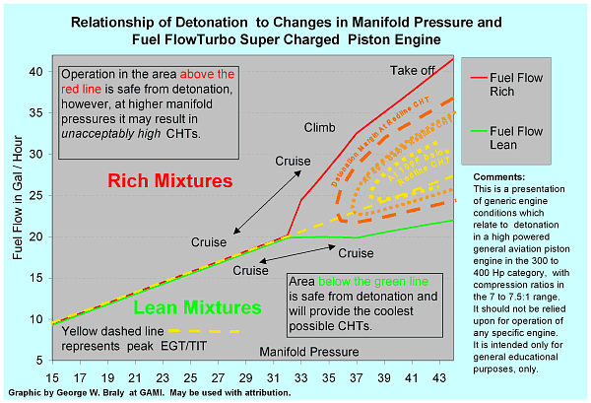
This new chart is simply a re-orientation of the old Curtis-Wright chart, using parameters that converted the "fuel-air" ratio scale of the old C-W Chart to a more pilot useful "rich of peak" - "lean of peak" scale that is familiar to pilots that fly with EGT gages. As noted, MP is across the bottom, and fuel flow up the left side. The yellow dashed line is the line of peak EGT. Note that along that line at about 36" MP and 22 GPH, we begin to risk detonation, but only if we are at redline CHT. If we push on to 37 to 38" and 23 - 24 GPH, we risk detonation even when the CHTs are cooled off some 50º F below redline CHT. Finally, if we can hold the CHT to 100º F under redline (high airspeed, open cowl flaps, etc.), you have to really work at it to find a MP and fuel flow combination that can cause detonation. Looking at the green line, we see that if we lean to just under peak EGT by some margin, starting at maybe 50 LOP and increasing to as much as 100F LOP at higher manifold pressure settings, detonation becomes pretty much impossible especially if the CHTs are kept at reasonable levels.
As a side note, the airframe OEM people and the engine OEM folks back in the '60s and '70's really did not do any of us any favors when they adopted the outrageously high "redline" CHT values that are used for certification. They should have spent a bit more time working on the baffling and cooling of these engines, and then marked down the redline CHT by about 50F. It would have paid them large dollar benefits in reduced warranty problems! Now look at the area to the upper right, and just rich of peak EGT (just above the yellow dashed line). This is exactly the area so beloved by Lycoming, where they insist it is best to operate. Finally, there is the red line, which tracks pretty closely with what we've always done when running ROP. As power is increased (MP), we pour large quantities of extra fuel into the mixture (making a very dirty mixture), in order to slow down the flame front, so that the peak pressure occurs later. At very high power, on some of these turbocharged engines, one has to stay very much (250 or 300 F or more) rich of peak in order to avoid detonation at full power, especially with the CHTs operating at very high values. Why not run LOP, which also slows the flame front, and makes the engine run cooler and cleaner, with lower internal component stresses at any given power setting? As we go to press with this, there are some very exciting developments. Testing continues at GAMI, the Australians have come out with a most interesting "Recommendation" as a result of a fatal crash, and a few other things I don't have permission to disclose at this time. We also need to talk a little about preignition. If reading about detonation gives you the willies, reading about preignition and seeing some real data will give you nightmares!
Be careful up there!

