Diamond DA-40 Transition Checkout

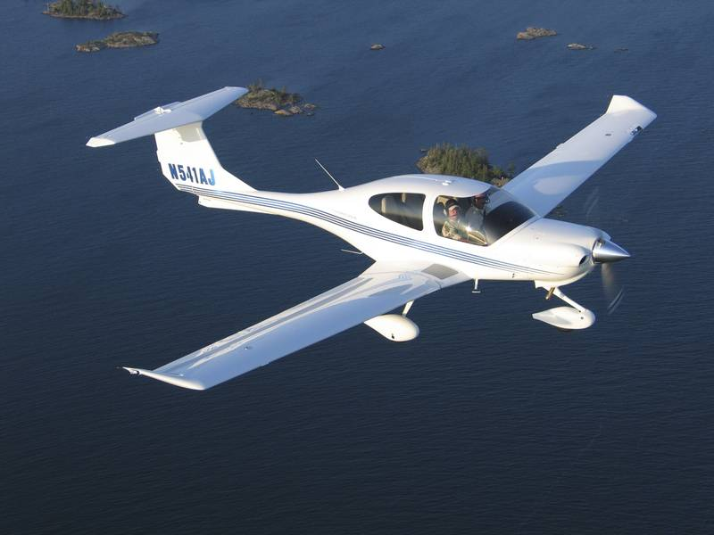

In preparation for your checkout flight, answer all of the following questions as completely and thoroughly as possible using the airplane’s POH . This checkout is designed for Plus One’s DA-40 Serial # 40-233.

Systems:

What’s the airplane structure made out of?

How are the control surfaces connected to the pedals and stick?

What controls the nose wheel steering?

What type and size (hp) engine does the airplane have?

What is the purpose of the alternate static air valve and where is it located?
What is the purpose of the alternate air valve and where is it located?

When should the auxiliary fuel pump be used:

What are the fuel selector positions and how do you turn it to “Off”:

How many fuel drains are there and where are they located:

Does this airplane have a fire extinguisher and, if so, where is it located:

Provide the following information found in the POH regarding fuel and oil:
Total Fuel Capacity: ____ Gals Usable Fuel: ____ Gals
Maximum permissible fuel imbalance: ____ gals
Grade of Fuel: ____ Color of Fuel: ____
Oil Capacity: ____ Minimum Oil: ____
Type & Weight of Oil: ____

If an engine indication on the VM1000 is flashing, it indicates:

If the “START” annunciator is illuminated after engine start, it indicates:

If the “PITOT” annunciator is illuminated, it indicates:

What does the “L FUEL” or “R FUEL” annunciator light indicate?

What fuel gauge reading can you expect when the tanks are full?

What are the following instruments powered by: Pneumatic (Vacuum or Pressure), Pitot-Static, Electric,
Backup Source (if available) ________
a) Attitude Indicator: ________
b) Heading Indicator: ________
c) Turn Coordinator: ________
d) Airspeed Indicator: ________
e) Vertical Speed Indicator: ________
f) Altimeter: ________

What is the normal system voltage?

Can you use the auxiliary plug to run your GPS?

How many batteries does the airplane have and what do they power?

What is the ESS Bus Switch and when do you use it?

What is an easy way to determine which systems the ESS Bus powers?

Can the starter be engaged with the Essential Bus Switch on?

How would an alternator malfunction be indicated?

What is the corrective action for alternator failure?

What is the corrective action for low voltage warning light?

When should the mixture be leaned?

What is the procedure for leaning the mixture for Best Economy?

What is the procedure for leaning the mixture for Best Power?

When should the mixture be enriched for decent and landing?

The rear canopy must have the release handle lock engaged for takeoff? True / False

The rear canopy may be opened in flight, e.g., for cooling or for photos?
True / False

On the ground, may you turn the airplane by pressing down on the empennage so the nose wheel is raised?

How do you find the nearest airport using GPS?

How do you determine if the #1 NAV is in NAV mode or GPS mode?

What are all the different ways the autopilot can be disengaged?

Does the autopilot hold heading, altitude, or both in this aircraft?

Operating Speeds

1,874 lbs 2,205 lbs 2,535 lbs
V_{R}
V_{Y Takeoff Flaps}
Cruise Climb _{Flaps Up}
Normal Landing _{Landing Flaps}
Minimum Landing _{Landing Flaps}
V_{SO}
V_{A}
V_{FE} Landing
V_{FE} Takeoff
V_{NO}
V_{NE}
Best Glide (1.5 miles per 1,000”)
Maximum Crosswind Component

Note: Full fuel, two 160 pound people with no baggage will weigh about 2,200 lbs. Therefore, in this configuration, the middle column V-speeds are the most appropriate.

What is MAM-40-227 and has it been performed on this airplane:

Can this airplane be intentionally spun? No What’s the recovery procedure for a spin?

For this airplane, what’s the maximum continuous power setting?

What’s the wing span and when might this present a problem?

Provide the following information for this airplane: :
Maximum Takeoff Weight _______ Useful Load ________
Maximum Landing Weight _______ Empty Weight ________

How much weight can you put in the baggage compartment?

You and your family want to fly to Big Bear (L35) Determine the following information regarding the aircrafts takeoff and climb limitations for the following conditions note the effects of high density altitude on takeoff and climb performance.
Field elevation= 6752 Ft. Altimeter= 29.80
Temperature= 80deg. F (which is ____ deg. C). Wind is 5 kts, tail wind
Aircraft weight= maximum takeoff (which is______ lbs.)
What is the airport pressure altitude=_______ft.
What is the density altitude of the airport: ________ft.
What is the runway length needed for:
Takeoff?__________ft. Landing? ___________ft
What is the minimum horizontal distance needed to clear a 50 ft. obstacle: Takeoff?__________ft. Landing? ___________FT

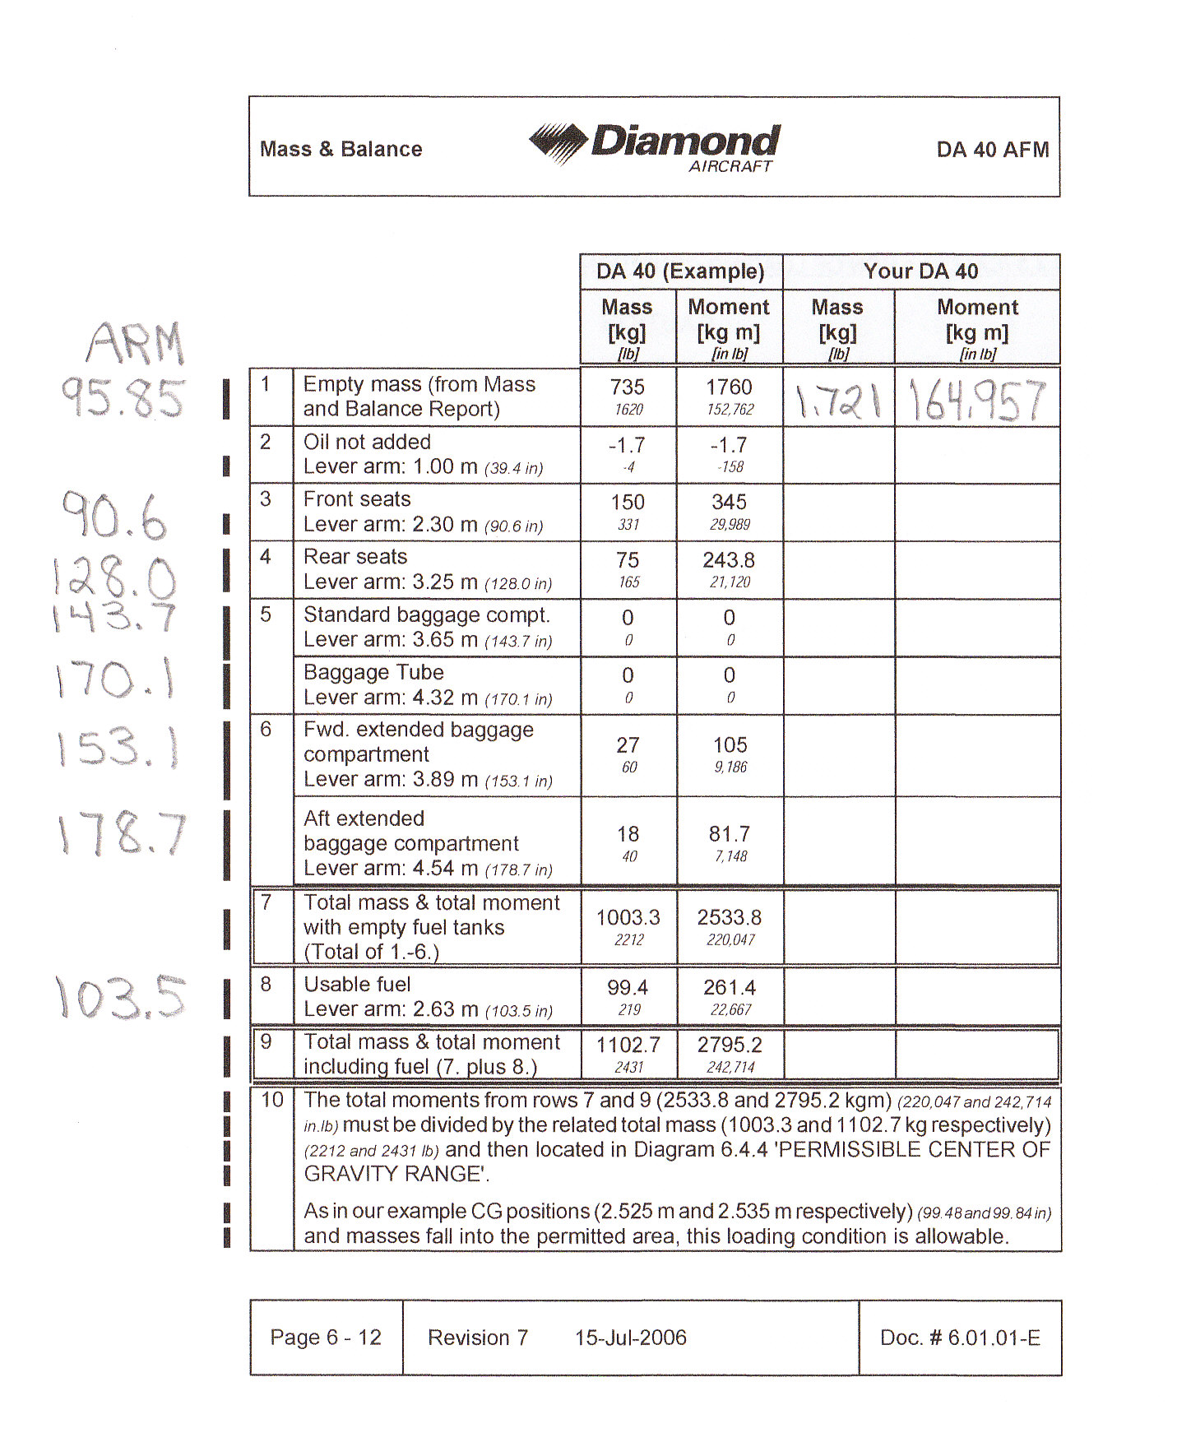
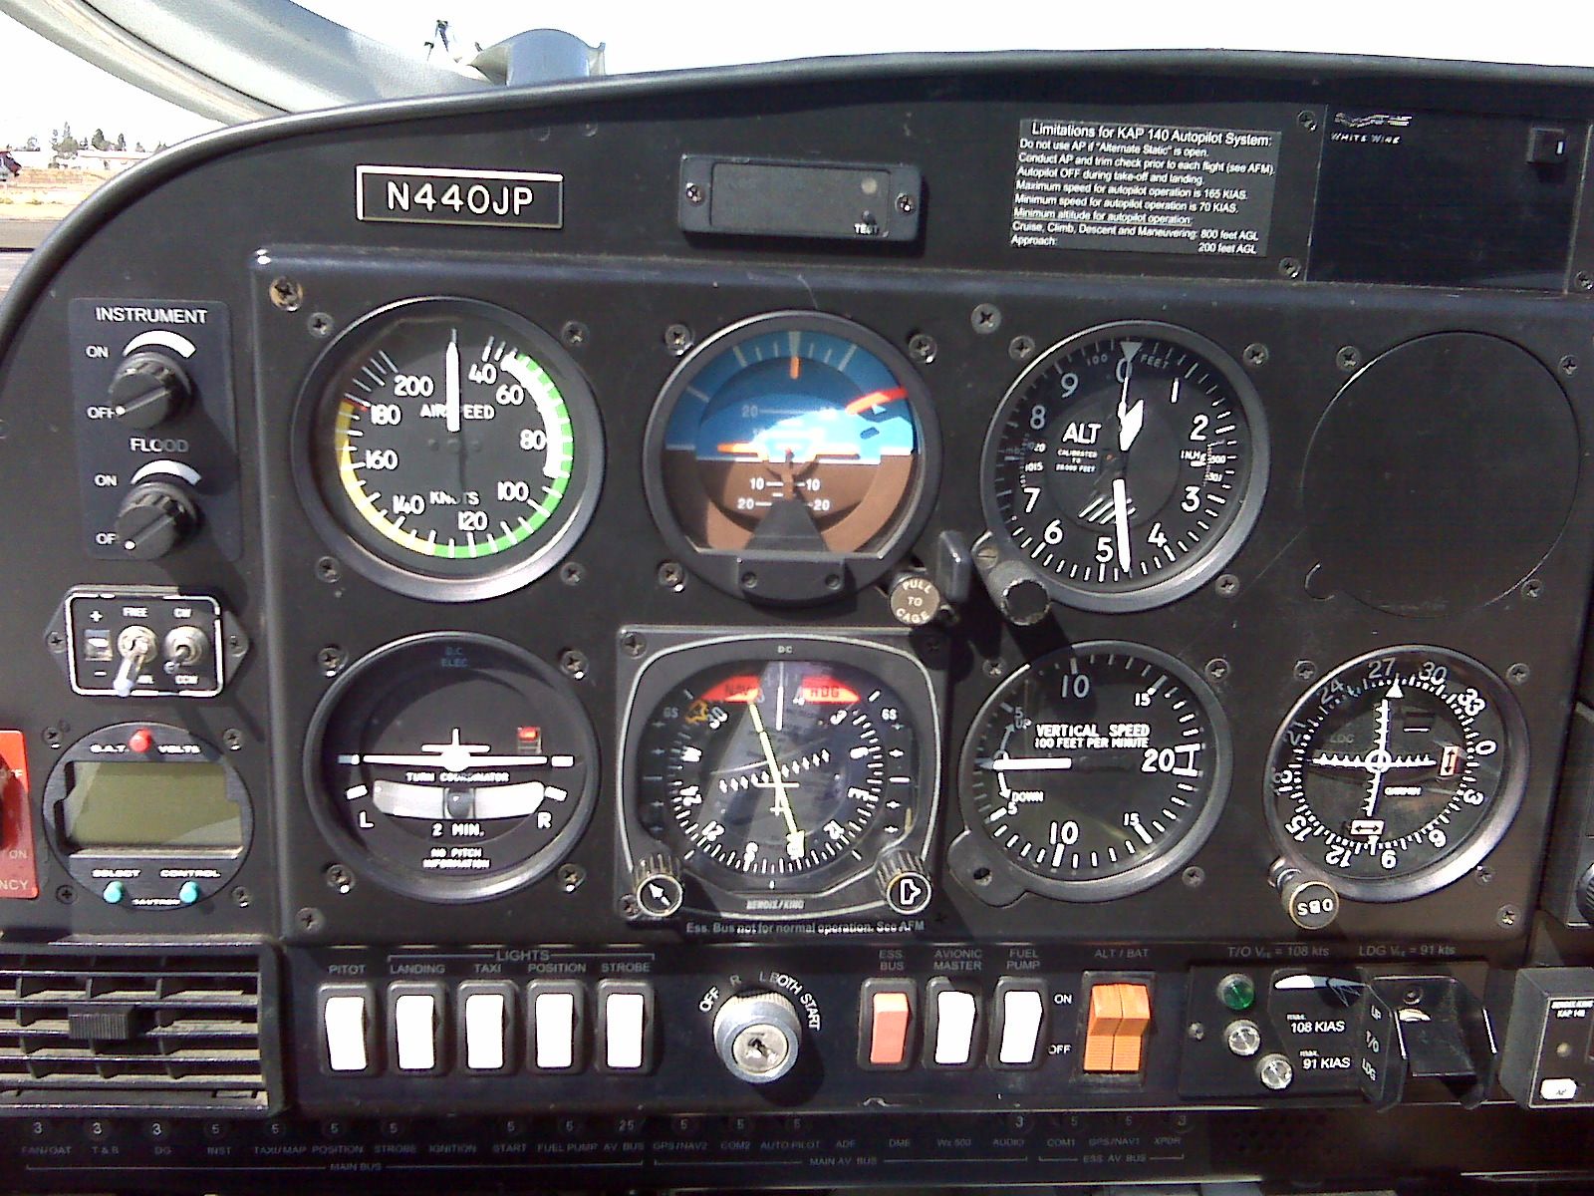
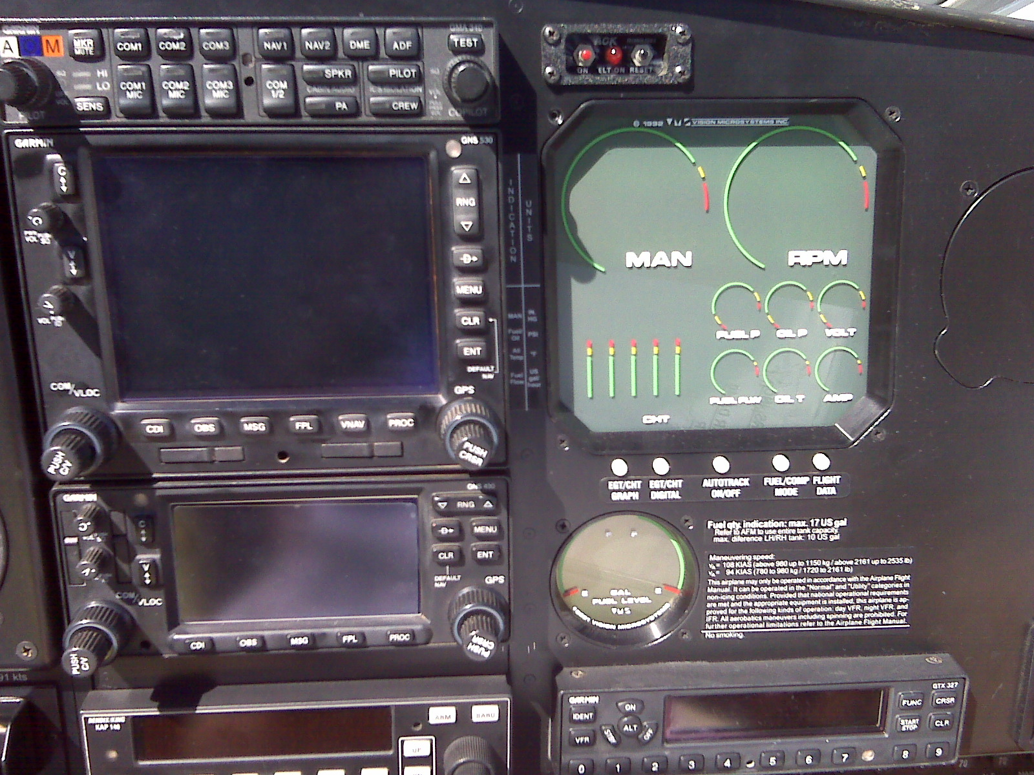
DA40 Transition Flight Checkout:

Preflight:
Clean design. Affect on slips, too high approach speed
Canopy visibility
Free castoring nose wheel
Winglets / Wing length
Stall strips at wing root edges
Tail protection strip
Fuel drain locations
Rear canopy latch, (pilot demonstrates both inside and outside latch)
HSI Free/ Slave switch
Pilot stick buttons
Ways to disconnect autopilot
Ess Buss
Emergency standby battery switches (DO NOT OPEN)
Fuel selector – (pilot demonstrates L, R and off positions)
Alt. Static Control (pilot demonstrates on/ off positions)
Alternate Air (pilot demonstrates on/off positions)
Fire extinguisher
Headset jacks, explain layout
Rudder pedal adjustment (pull cable straight back)

Flight:
Passenger brief: (glare shield shakes, overly sensitive stall horn)
Flap use on T/O’s
Controllable pitch prop
Stick forces
Trim
Stalls, Power on and power off (demo: stick all the way back)
Steep turns
Autopilot use
Basic GPS use
Go around: (problem area: complete flap retraction)

Shut Down:
Tow Bar use
Wing clearance
Gust lock

